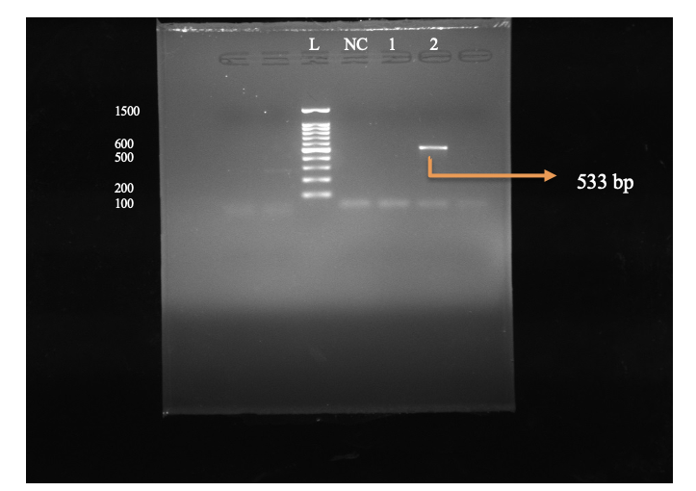

Methicillin Resistant genes of *Staphylococcus aureus* detected by MecA primer design confirming 533 bp bands, L: Ladder, NC: Negative Control, Lanes

1-2 field sample

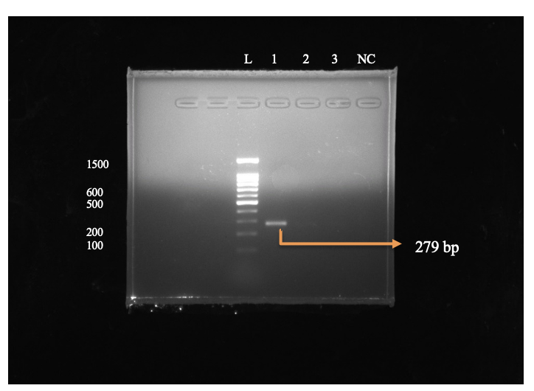

Nuc genes of *Staphylococcus aureus* detected by Nuc primer design confirming

279 bp bands, L: Ladder, NC: Negative Control, Lanes

1-3 field sample

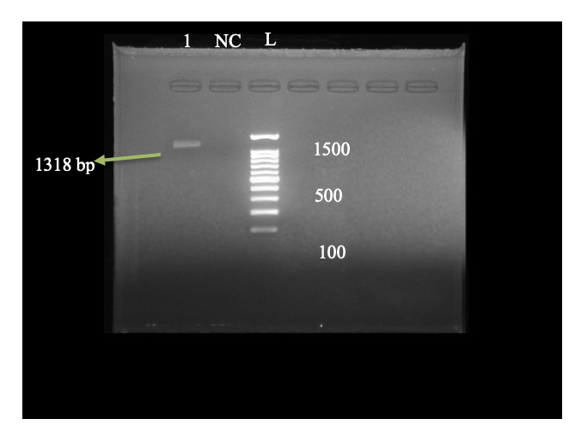

*23S rRNA* genes of *Staphylococcus aureus*detected by Sau- 327(F) and Sau- 1645 (R) primer design confirming 1318 bp bands, L: Ladder, NC: Negative Control, Lanes 1 field sample

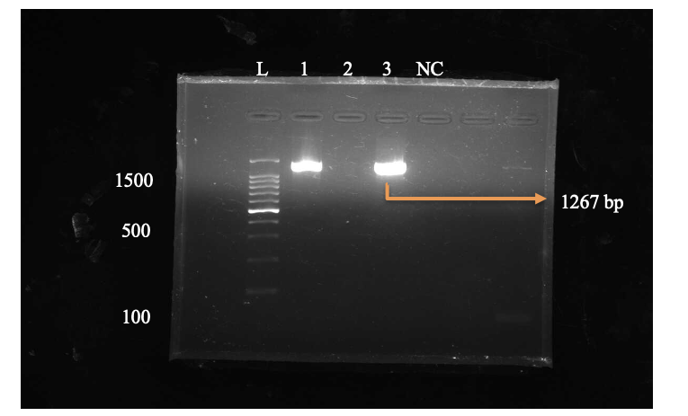

*23S rRNA*genes of *Staphylococcus aureus*detected by Sau- 234 (F) and Sau- 1501 (R) primer design confirming 1267 bp bands, L: Ladder, NC: Negative Control, Lanes 1-3 field sample.

Table S1: Precise inclusion criteria

Note: Farm 1: Roy Goat Farm: (Sadar Dinajpur)

Farm 2: Yeamin and Brothers Goat Farm:(Parbatipur, Dinajpur)

Farm 3: Sarkar Goat farm: (Birol, Dinajpur)

Farm 4: Nasir and Sons Agro Farm: (Chirirbandar, Dinajpur)

Mastitis scoring 1: Abnormal milk

Mastitis scoring 1: Abnormal milk + Inflated of udder

|  |  |  |  |  |  |
| --- | --- | --- | --- | --- | --- |
| Sample number | Farm with location | Mastitis score | Parity | Days in Milk (DIM) | Yield milk/ml |
| 1 | 1 | 1 | 2 | 15 | 500 |
| 2 | 1 | 2 | 1 | 15 | 350 |
| 3 | 1 | 2 | 3 | 15 | 300 |
| 4 | 1 | 2 | 1 | 15 | 800 |
| 5 | 1 | 1 | 3 | 20 | 750 |
| 6 | 1 | 1 | 2 | 20 | 1000 |
| 7 | 1 | 1 | 1 | 20 | 850 |
| 8 | 1 | 1 | 2 | 35 | 1000 |
| 9 | 1 | 1 | 1 | 35 | 600 |
| 10 | 1 | 1 | 3 | 35 | 650 |
| 11 | 1 | 1 | 1 | 15 | 500 |
| 12 | 1 | 1 | 2 | 15 | 500 |
| 13 | 1 | 1 | 3 | 14 | 500 |
| 14 | 1 | 1 | 3 | 12 | 450 |
| 15 | 1 | 1 | 2 | 16 | 450 |
| 16 | 1 | 1 | 1 | 16 | 650 |
| 17 | 1 | 1 | 1 | 18 | 600 |
| 18 | 1 | 1 | 1 | 20 | 390 |
| 19 | 2 | 1 | 1 | 20 | 520 |
| 20 | 2 | 1 | 2 | 15 | 450 |
| 21 | 2 | 1 | 2 | 15 | 480 |
| 22 | 2 | 2 | 2 | 21 | 580 |
| 23 | 2 | 1 | 2 | 23 | 450 |
| 24 | 2 | 2 | 1 | 28 | 450 |
| 25 | 2 | 2 | 3 | 24 | 450 |
| 26 | 2 | 2 | 1 | 20 | 500 |
| 27 | 2 | 1 | 3 | 15 | 500 |
| 28 | 2 | 1 | 2 | 15 | 650 |
| 29 | 2 | 0 | 2 | 20 | 650 |
| 30 | 2 | 1 | 1 | 20 | 700 |
| 31 | 2 | 0 | 1 | 20 | 700 |
| 32 | 2 | 1 | 2 | 45 | 750 |
| 33 | 3 | 1 | 2 | 36 | 850 |
| 34 | 3 | 0 | 1 | 34 | 1200 |
| 35 | 3 | 1 | 2 | 18 | 1100 |
| 36 | 3 | 0 | 1 | 18 | 950 |
| 37 | 3 | 2 | 2 | 15 | 750 |
| 38 | 3 | 1 | 3 | 15 | 680 |
| 39 | 3 | 1 | 2 | 30 | 500 |
| 40 | 3 | 2 | 3 | 30 | 850 |
| 41 | 4 | 0 | 1 | 25 | 950 |
| 42 | 4 | 1 | 2 | 25 | 1000 |
| 43 | 4 | 9 | 1 | 25 | 1000 |
| 44 | 4 | 1 | 2 | 22 | 890 |
| 45 | 4 | 1 | 2 | 20 | 560 |
| 46 | 4 | 1 | 2 | 15 | 500 |